Logan MacPhail

loganmacphail2026@u.northwestern.edu

MacPhail Quantitative Investment Firm

Performance Evaluation

The MacPhail Quantitative Investment Firm (MQIF) is focused on combining optimal long-term growth with risk-adjusted returns over the next five years. MQIF is the ideal firm for the low-risk investor seeking a quantitative approach to investing. We’ll break down MQIF’s performance evaluation process below, showing you how you can still make money over five years without risking too much.

**Performance Evaluation**

         To evaluate the performance of the portfolio, backtesting is applied over different periods to assess how the methodology would perform in various scenarios. Performance can be evaluated in various market environments or during extreme scenarios to determine how resilient the portfolio is in terms of risk. Because the ETFs and their associated weights are dynamically chosen, the portfolio methodology can be tested over any period. The portfolio can also be evaluated across various metrics, including returns, volatility, the Sharpe ratio, Beta, and Alpha. Given the goals of long-term growth and risk-adjusted returns, it makes sense to compare the portfolio against similar strategies. A 60/40 split of the S&P 500 (SPY) and the US Aggregate Bond ETF (AGG) over the same periods provides a good benchmark of a portfolio that’s heavily focused on equities and bonds.

Since we're evaluating the strategy over five years, MQIF's portfolio is evaluated against every five-year stretch since the year 2000. For example, 2000-2004, 2001-2005, 2002-2006, would all be permutations to evaluate. This enables MQIF to evaluate the portfolio in both strong and weak market conditions. The 2008 Financial Crisis, as well as the COVID-19 pandemic in 2020, give good opportunities to evaluate the portfolio in extreme conditions to prove its ability to limit risk.

**Performance Summary**

Rather than look at every permutation from 2000 to 2025, we'll focus on a subset of five year stretches that encompass the 2008 Financial Crisis and the 2019 COVID-19 pandemic. Below is a chart comparing the Sharpe Ratios of the MQIF portfolio vs. the 60/40 split of SPY and AGG

Unfortunately, the 60/40 SPY/AGG portfolio has higher Sharpe Ratios in each five year split except the 2005 to 2010 stretch. We can see in the chart below that the MQIF has higher returns than the 60/40 SPY/AGG split in 4 of the 7 periods.

However, if we look at the volatility of the portfolios in each period, we can see that the MQIF is experiencing higher volatility consistently compared to the SPY/AGG portfolio.

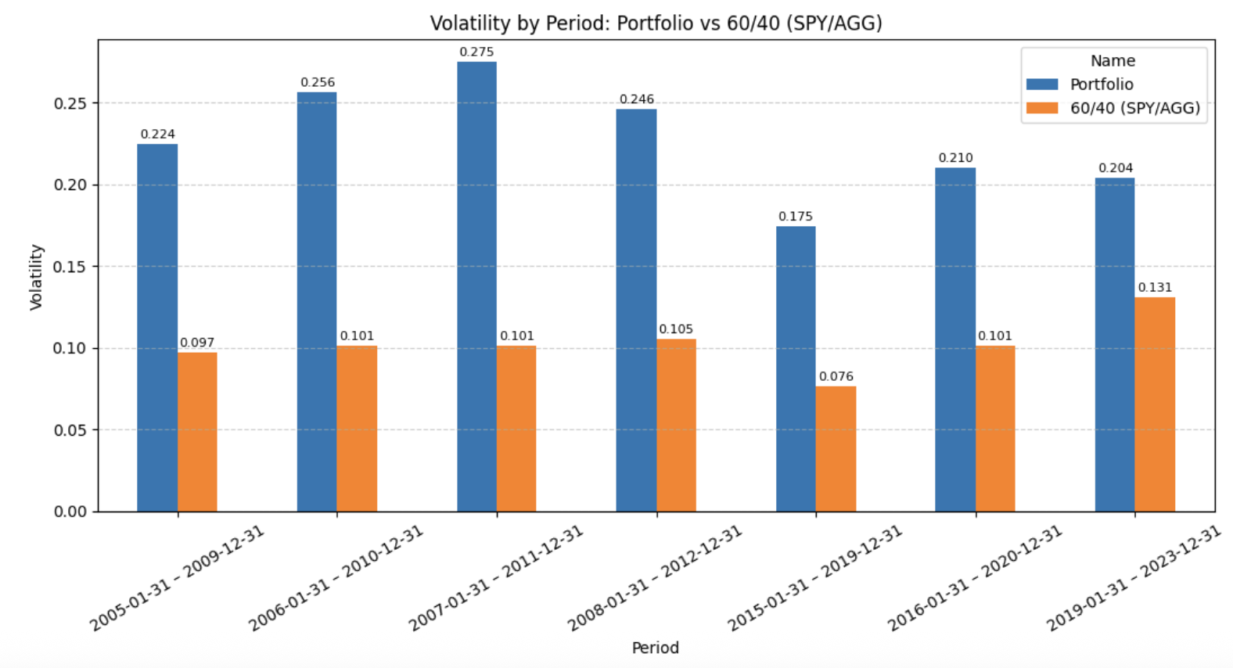

**Compensation**

         Given that the portfolio's focus is on long-term growth, risk-adjusted returns, and minimizing risk over a five-year period, compensation is derived from a combination of management fees and performance fees. The management fee is low and transparent, given that we’re managing a systematic ETF portfolio. MQIF charges 0.50% annually. Since MQIF optimizes for risk-adjusted returns, performance fees are tailored around our performance against the 60/40 SPY + AGG benchmark or the AOM. MQIF charges 15% of the excess alpha above the SPY + AGG or AOM. MQIF is compensated when it outperforms realistic alternatives for clients seeking a similar investment approach. MQIF is also compensated 15% of returns that are above a 1.0 Sharpe Ratio. This ensures that MQIFs' incentives are the same as those of its investors in terms of protecting capital and compounding smartly.